FOR IMMEDIATE RELEASE

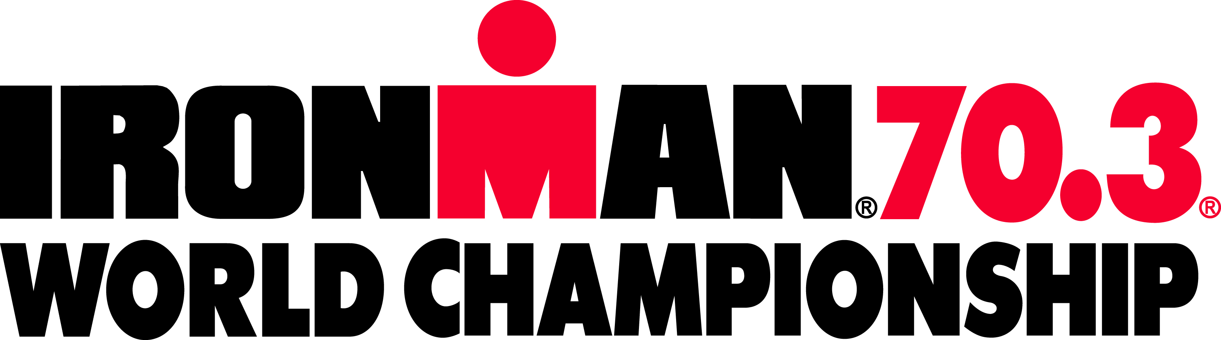

2015 IRONMAN 70.3 WORLD CHAMPIONSHIP TO BE HELD IN EUROPE
Luxembourg, Zell am See-Kaprun, Nice and Haugesund Named as Finalists

TAMPA, Fla. (November 19, 2013) – IRONMAN today announced that the 2015 IRONMAN® 70.3® World Championship triathlon will be held in Europe. Four cities, all of which currently host IRONMAN® races, have been selected as the finalists – Haugesund (Norway), Luxembourg, Nice (France) and Zell am See-Kaprun (Austria).

As announced earlier this year, the location of the IRONMAN 70.3 World Championship will rotate annually. The 2014 championship will be held in Mont-Tremblant, Quebec on September 7. More than 2,500 domestic and international competitors will earn the right to compete in the IRONMAN 70.3 World Championship by qualifying at IRONMAN 70.3 events around the world.

“We are excited to bring the IRONMAN 70.3 World Championship to Europe in 2015. Already tremendous hosts to IRONMAN races, these four finalist cities provide scenic and challenging courses suited for a World Championship event,” said Andrew Messick, Chief Executive Officer of IRONMAN.

Finalists:
- Haugesund, Norway – The Norwegian town of Haugesund hosted IRONMAN 70.3 races in 2012 and 2013. Haugesund provides athletes with a beautiful and challenging course – as well as thousands of spectators lining the streets cheering on the athletes.
- Region Moselle, Luxembourg –Luxembourg made its mark on the European IRONMAN map by hosting the inaugural IRONMAN 70.3 Luxembourg in 2013. The scenic swim course borders both Luxembourg and Germany.
- Nice, France – Host to IRONMAN France, the City of Nice needs no introduction to the world-wide triathlon community. Swim in the Mediterranean, bike through the Alps and run along Nice's historic waterfront.
- Zell am See-Kaprun, Austria – Located only an hour’s drive from Salzburg, this picture-perfect town is located in the Austrian Alps. Athletes enjoy the crystal-clear water of the Zeller See and breathtaking views of mountain meadows and glacier-covered peaks.

“I am extremely happy about these four finalists – as they are already great ambassadors for the sport of triathlon. All of them would be fantastic hosts for the world’s most elite IRONMAN 70.3 athletes,” adds Thomas Dieckhoff, Chief Executive Officer of IRONMAN Europe, Middle East and Africa.

Nearly 150,000 athletes will participate in the global IRONMAN 70.3 Series during the 2014-2015 season, which consists of over 70 events in locations such as Australia, Brazil, Malaysia and South Africa. Participants in the IRONMAN 70.3 World Championship will range in age from 18 to 80-plus and will represent over 50 countries. Each age-group winner at the 2014 IRONMAN 70.3 World Championship will automatically qualify for the 2015 championship.

For more information about the 2014 IRONMAN 70.3 World Championship, please visit www.ironman.com/triathlon/events/ironman-70.3/world-championship. For media related inquiries, please email media@ironman.com.
###

About IRONMAN
The iconic IRONMAN® Series of events is the largest participation sports platform in the world. Since the inception of the IRONMAN® brand in 1978, athletes have proven that ANYTHING IS POSSIBLE® by crossing finish lines at the world’s most challenging endurance races. Recognized for excellence through distinguished events, world-class athletes and quality products, IRONMAN has grown from a single race to a global sensation with more than 190 events across five unique brands: IRONMAN®, IRONMAN 70.3®, 5150™ Triathlon Series, Iron Girl® and IronKids®. For more information, visit www.ironman.com.

Media Contact:
Ellie Seifert, IRONMAN
ellie.seifert@ironman.com
(P) 813.868.5914

